CIT 515 Project 2B Report

Collaborators: Han Yang Lim / Alex Newman Ilgenfritz

**Part I:**

After applying the function *Harr_inv2D* to the matrix *T* we get the following result:

res_T = [576 704 1152 1280 1344 1472 1536 1536

704 640 1152 1088 1344 1408 1536 1600

768 832 1216 1472 1472 1536 1600 1600

832 832 960 1344 1536 1536 1600 1536

832 832 960 1216 1536 1600 1536 1536

960 896 896 1088 1600 1600 1600 1536

768 768 832 832 1280 1472 1600 1600

448 768 704 640 1280 1408 1600 1600]

This is the same matrix as *Pbad* displayed below except for a typo that has been highlighted:

*Pbad* = [576 704 1152 1280 1344 1472 1536 1536

704 640 1156 1088 1344 1408 1536 1600

768 832 1216 1472 1472 1536 1600 1600

832 832 960 1344 1536 1536 1600 1536

832 832 960 1216 1536 1600 1536 1536

960 896 896 1088 1600 1600 1600 1536

768 768 832 832 1280 1472 1600 1600

448 768 704 640 1280 1408 1600 1600]

**Part II: Image Transformation**

Xduerer:

*Haar2D* on *Xdurer­* with colormap jet: Outline points/ texture clearly visible.

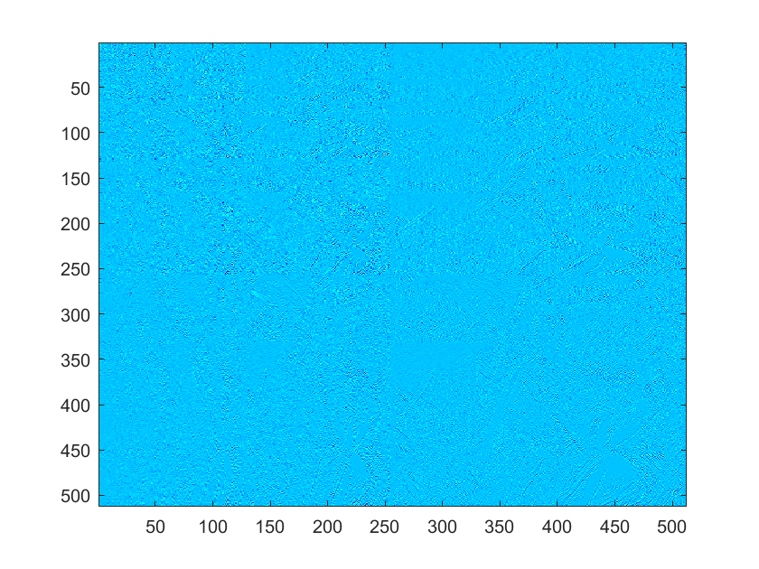

*Haar2D* on *Xdurer­* with colormap flag: All textural details clearly visible.

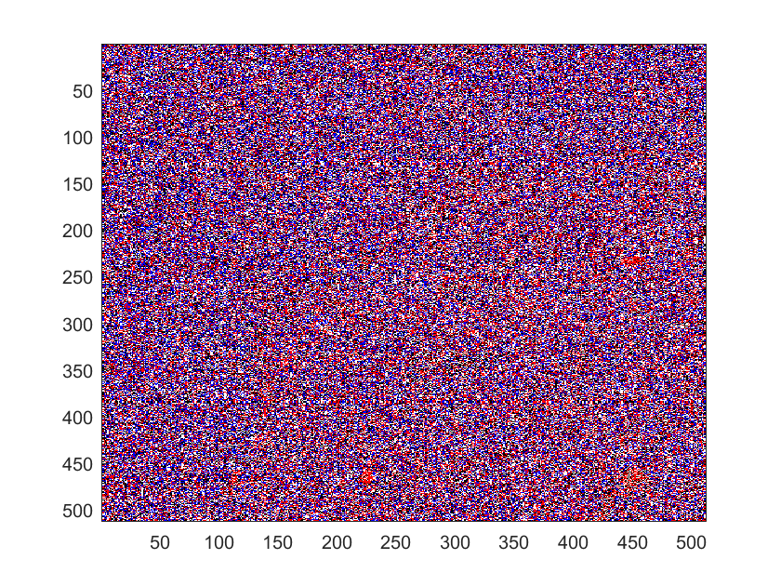

After immediate decoding\reconstructing it we get back the original image:

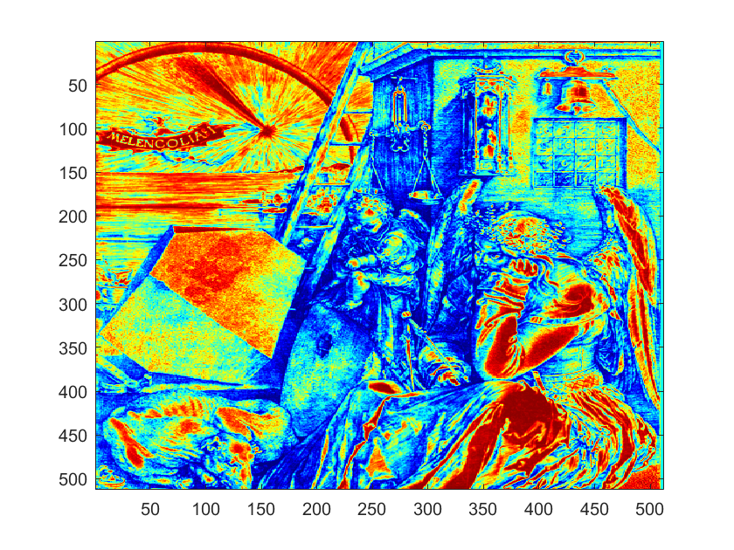

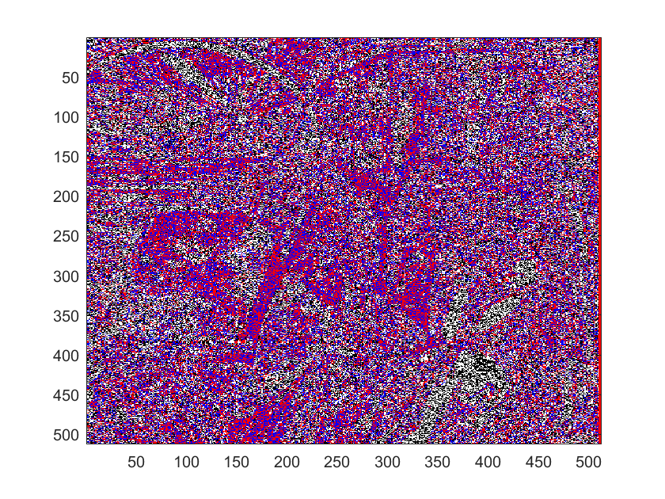

Using a threshold with colormap jet, we set the absolute value coefficients of the transformed image to zero.

Threshold of 10: Points are still clearly visible.

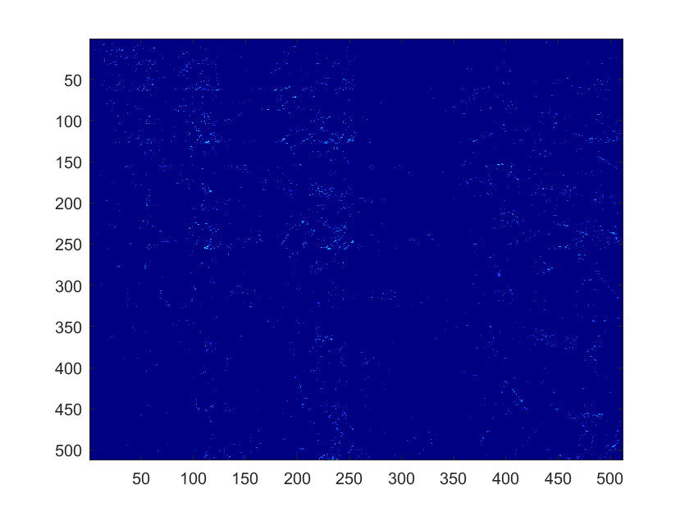

Threshold of 20: No points are visible. Fewer points are visible.

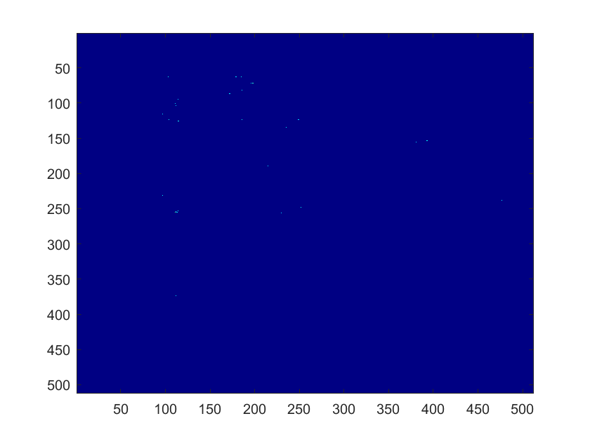

Threshold of 50: No points are visible.

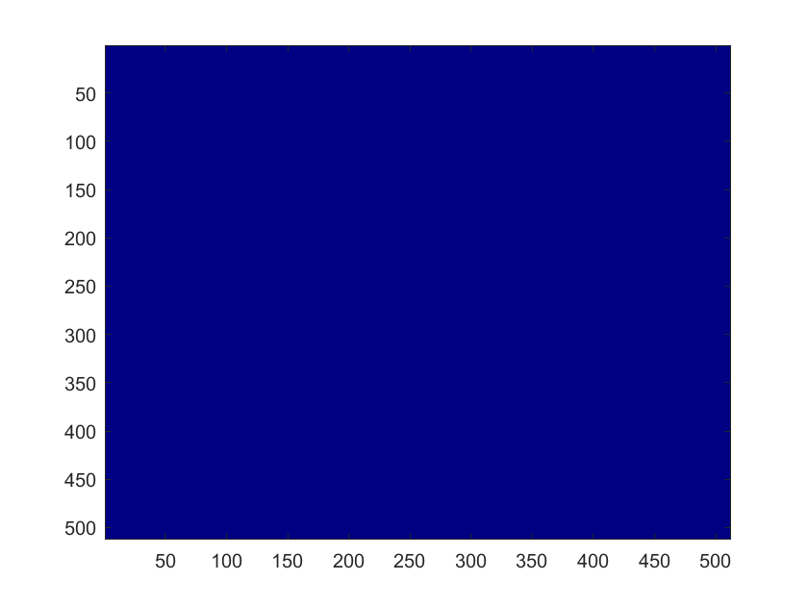

Threshold of 100: Color change.

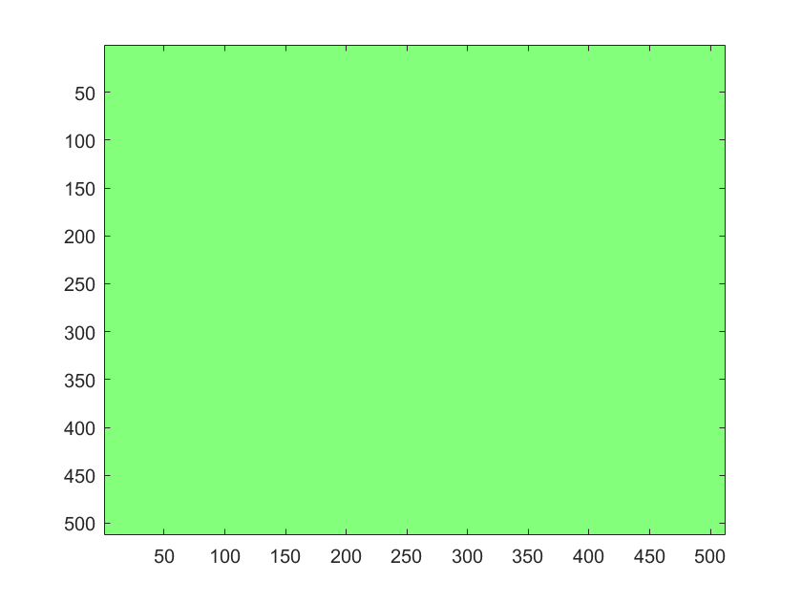

Using a threshold with colormap flag, we set the absolute value coefficients of the transformed image to zero.

Threshold of 10: Points are still clearly visible.

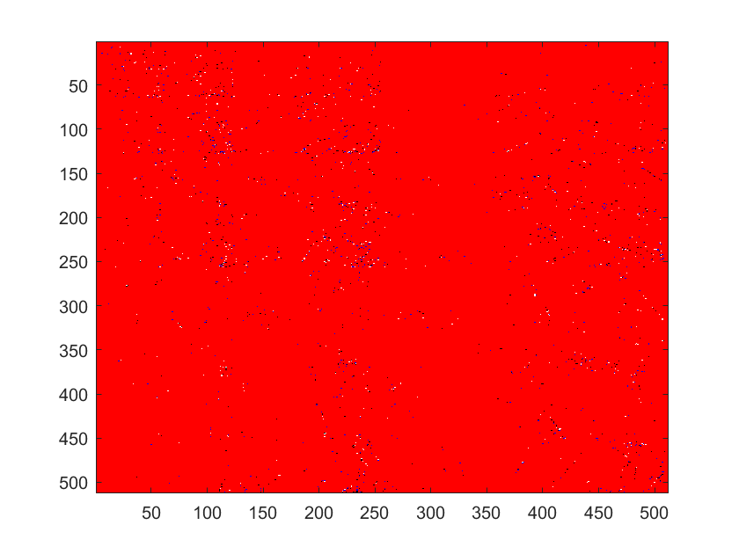

Threshold of 20: No points are visible. Fewer points are visible.

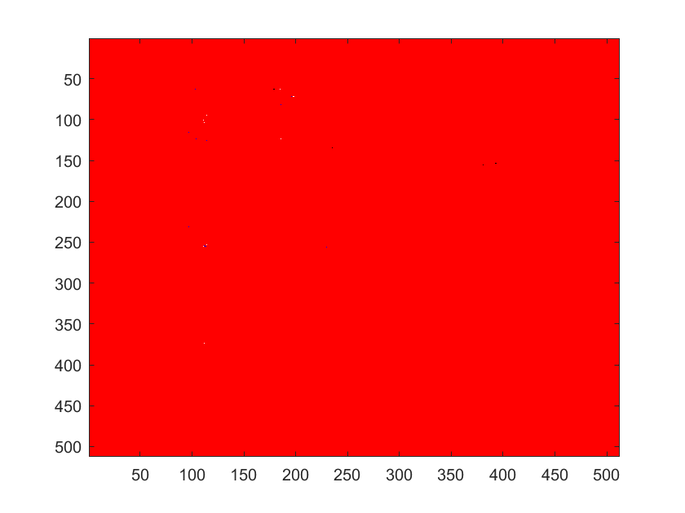

Threshold of 50: No points are visible.

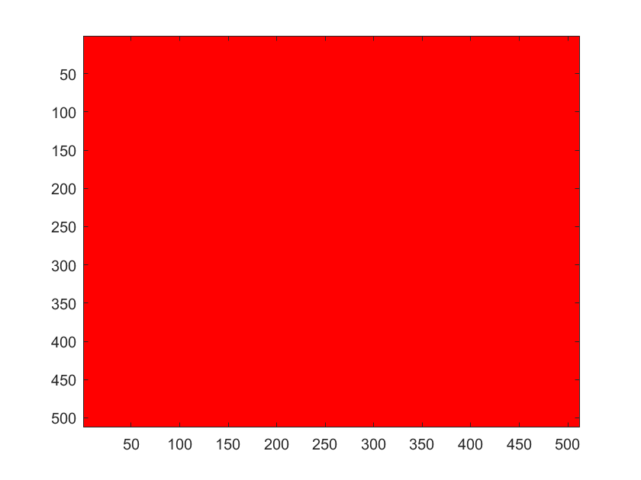

*Earth:*

*Haar2D* on *Earth* with colormap jet: Outline points/ texture clearly visible.

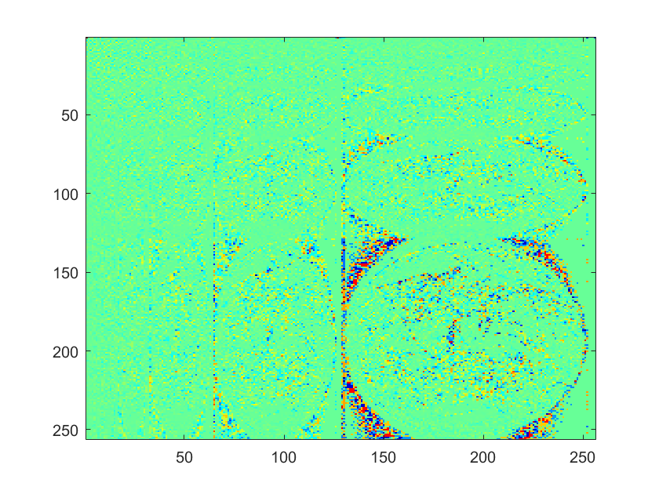

*Haar2D* on *Earth­* with colormap winter: All textural details clearly visible.

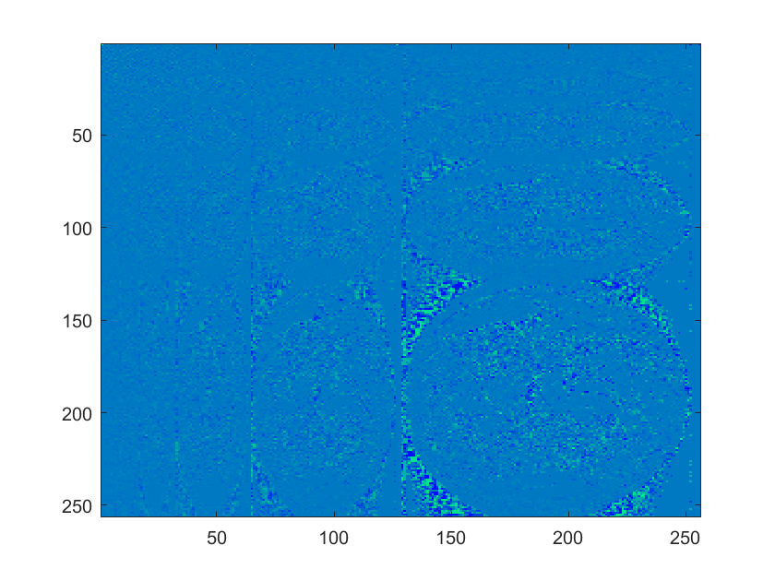

After immediate decoding\reconstructing it we get back the original image:

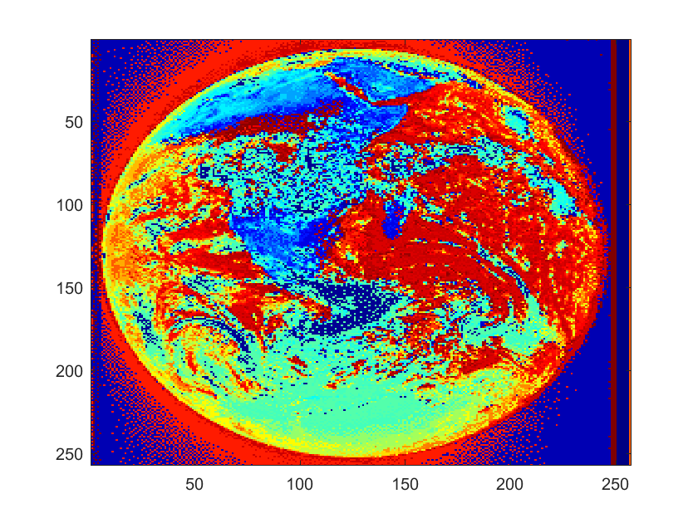

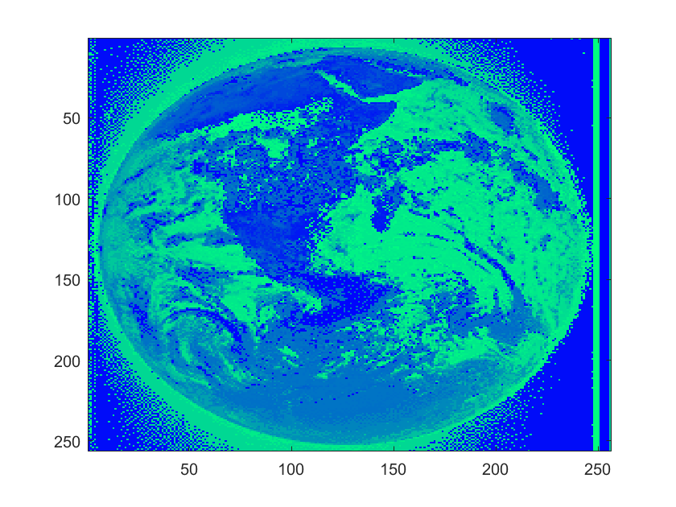

Using a threshold with colormap jet, we set the absolute value coefficients of the transformed image to zero.

Threshold of 10: Points are still clearly visible and segregated.

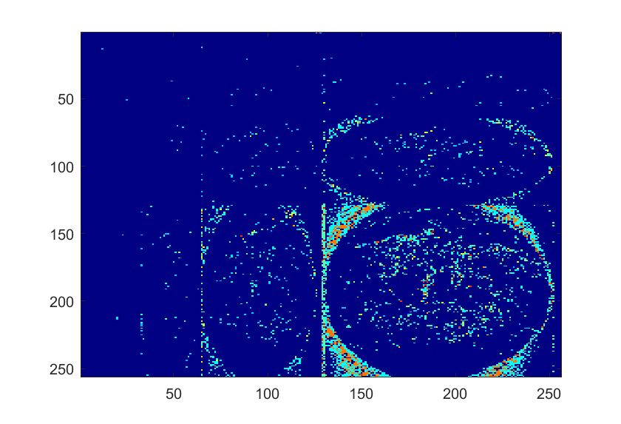

Threshold of 20: No points are visible. Fewer points are visible.

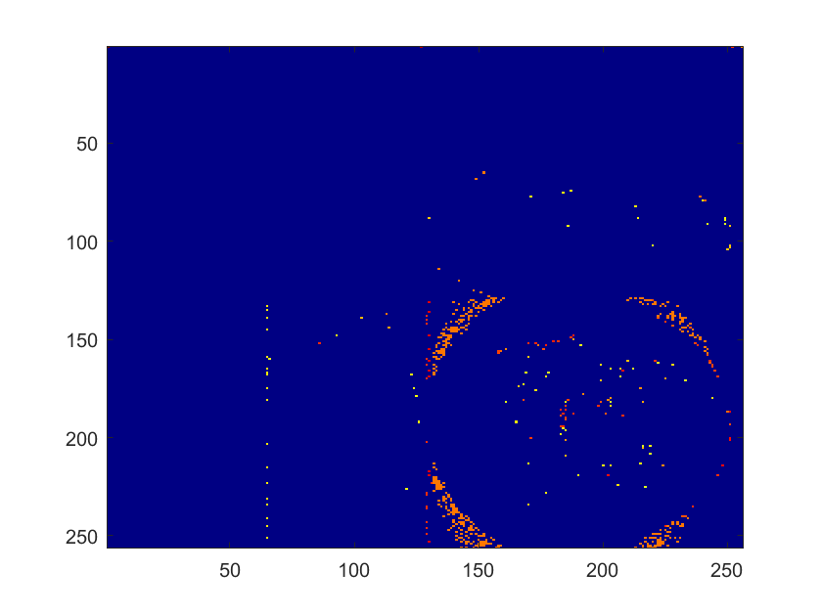

Threshold of 50: No points are visible.

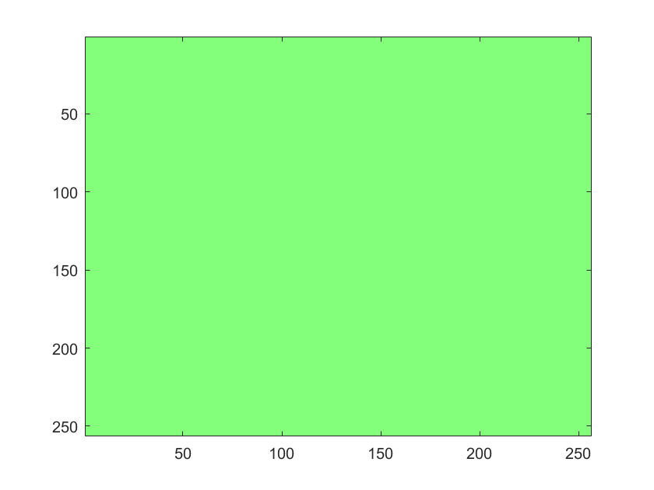

Threshold of 100: Same Image



Using a threshold with colormap winter, we set the absolute value coefficients of the transformed image to zero.

Threshold of 10: Points are still clearly visible.

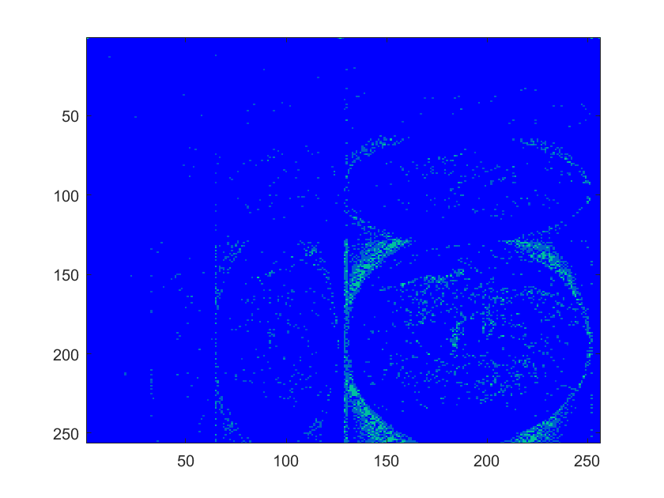

Threshold of 20: No points are visible. Fewer points are visible.

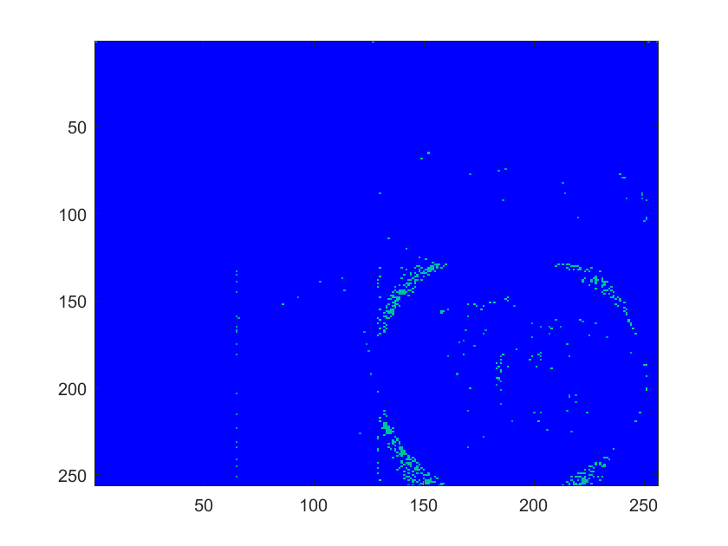

Threshold of 50: No points are visible.

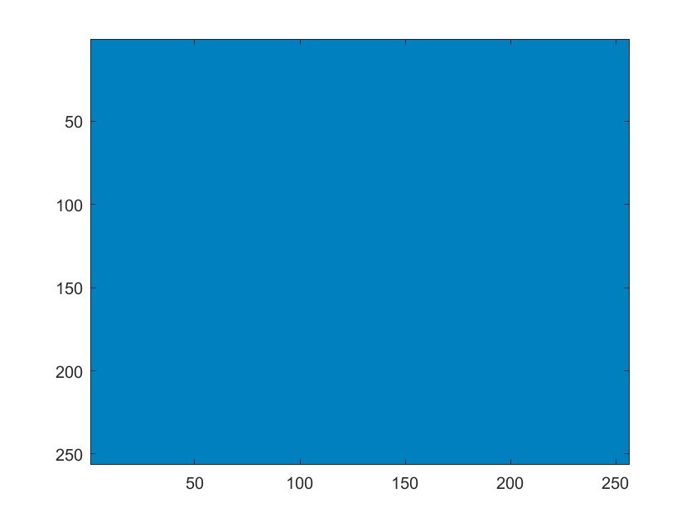

Conclusion: The larger the threshold of zero value coefficients, the more irreversible the image becomes due to more pixels becoming visibly and structurally removed.

**Part III:**

Use *haar2d_n* to compute the normalized matrix *C* of Haar coefficients of *A*:

1. Apply *haar2D_n* to *A*, obtaining *C0.*

C0 = [682.1250 51.8750 15.2028 21.3900 6.2500 2.7500 8.2500 8.0000

77.8750 5.6250 -7.7782 22.0971 -5.2500 -4.2500 1.7500 7.5000

7.7782 -13.7886 -7.7500 6.7500 0.7071 -5.3033 -1.4142 2.4749

38.3605 -0.5303 -3.2500 2.0000 -3.1820 1.4142 -1.7678 0.3536

-17.0000 11.5000 6.7175 -1.0607 -4.0000 6.5000 -5.0000 -4.5000

3.5000 -9.5000 -2.8284 -2.1213 -10.0000 6.0000 -5.0000 6.0000

8.2500 4.7500 -2.8284 1.7678 1.5000 -0.5000 -1.0000 0.5000

15.0000 4.5000 6.0104 6.0104 3.0000 -1.5000 -0.5000 4.0000]

1. Apply the command round to C0 to obtain a matrix C1 with integer entries.

C1 = [682 52 15 21 6 3 8 8

78 6 -8 22 -5 -4 2 8

8 -14 -8 7 1 -5 -1 2

38 -1 -3 2 -3 1 -2 0

-17 12 7 -1 -4 6 -5 -5

4 -10 -3 -2 -10 6 -5 6

8 5 -3 2 1 0 -1 0

15 5 6 6 3 -1 0 4]

3. Set to zero all entries of absolute value strictly less than 10 in C1 to obtain C2.

C2 = [82 52 15 21 0 0 0 0

78 0 0 22 0 0 0 0

0 14 0 0 0 0 0 0

38 0 0 0 0 0 0 0

17 12 0 0 0 0 0 0

0 10 0 0 10 0 0 0

0 0 0 0 0 0 0 0

15 0 0 0 0 0 0 0]